The Impact of AI on the Data Analytics Profession
Policy Brief · Professional English C1 · October 2026
Prepared by: Yermekov Dias, Yernar, Bauyrzhan · Group [ADA-2603M] · Astana IT University

Key messages
- AI is changing data analytics, not replacing it. AI tools now write queries, clean data, and draft reports. Yet demand for data professionals keeps rising: US employment of data scientists is projected to grow by 33.5% in 2024–34, compared with 3.1% for all occupations (U.S. Bureau of Labor Statistics [BLS], 2026).
- The entry route into the profession is at risk. In the occupations most exposed to AI, employment of workers aged 22–25 has fallen by about 13% relative to other groups, mainly because firms hire fewer young people (Brynjolfsson, Chandar, & Chen, 2025).
- Unchecked AI output lowers the quality of decisions. When consultants used AI on a task beyond its capabilities, they were 19 percentage points less likely to reach a correct answer (Dell'Acqua et al., 2023).
- The skills mix is shifting. Employers expect 39% of workers' core skills to change by 2030 (World Economic Forum, 2025). Analysts will need less routine coding and more judgement, verification, and communication.
- We recommend two actions: (1) universities should add a compulsory module on AI-assisted analytics and verification to data degrees; (2) employers and professional bodies should offer paid junior apprenticeships and require a named analyst to sign off any AI-generated analysis used for decisions.

1. Context and Problem Statement

1.1 How AI is changing data analytics
AI is changing how we do our jobs and which skills we need to adapt to these changes. The OECD has already recognized that AI is changing how workers perform their jobs and the skills they require (OECD, 2024). Until recently, a junior data analyst might spend two days writing SQL or Python code to build a weekly report. Today, with the help of an AI assistant, the same task might take about an hour. The analyst’s role then shifts towards checking the results and explaining what they mean. These changes are visible across all professions. According to the World Economic Forum (2025), big data specialists are the fastest-growing job role in percentage terms by 2030, while data entry clerks are among the fastest-declining roles.

1.2 Who is affected
These changes affect several groups: students and recent graduates in IT and data analytics, people working as data analysts, employers who hire analysts, and universities. The groups most directly affected are data analytics students, recent graduates, and current analysts, as the skills required for these roles change. These changes also matter for employers and universities, which need to adapt their hiring requirements and educational programs.

1.3 Key employment risks
The evidence points to three main risks for the profession: fewer entry-level opportunities, lower quality and unclear accountability, and a widening skills gap.

Risk 1: A shrinking entry route
Routine tasks such as checking and validating data and writing basic SQL queries have traditionally been the training ground for junior analysts. If AI takes over these tasks, employers may hire fewer junior analysts, making it harder for recent graduates to gain their first work experience. Early evidence points in this direction. Employment of workers in the US aged 22–25 in the occupations most exposed to AI has fallen by about 13% relative to comparison groups (Brynjolfsson, Chandar, & Chen, 2025). In the long term, hiring and training fewer juniors could leave the profession with fewer experienced data analysts who understand the reasoning behind their work.

Risk 2: Lower quality and unclear accountability
AI can produce analysis that looks convincing but may be wrong. When no one checks it, errors in AI-generated analysis can lead to errors in decision-making. It may also be unclear who is responsible for these errors. In one field experiment, consultants who used AI on a task beyond its capabilities were 19 percentage points less likely to reach a correct answer than those working without AI (Dell’Acqua et al., 2023). It may also be unclear who is responsible for these errors.

Risk 3: A widening skills gap
Skills are changing quickly, and employers and students may not learn them fast enough. According to the World Economic Forum (2025), 39% of workers’ core skills are expected to change by 2030, and 63% of surveyed employers identify skills gaps as a major barrier to business transformation. This means that graduates may enter the job market without some of the skills they need.

1.4 Why the issue needs attention now
This issue needs attention now because AI is already part of software that data analysts use every day, including spreadsheets, BI tools, and code editors. Its impact is likely to grow as these AI features become more widely used. Eloundou et al. (2024) estimate that large language models alone could affect over half of the tasks in about 1.8% of US jobs. This share rises to just over 46% when current and likely future software built around these models is taken into account.
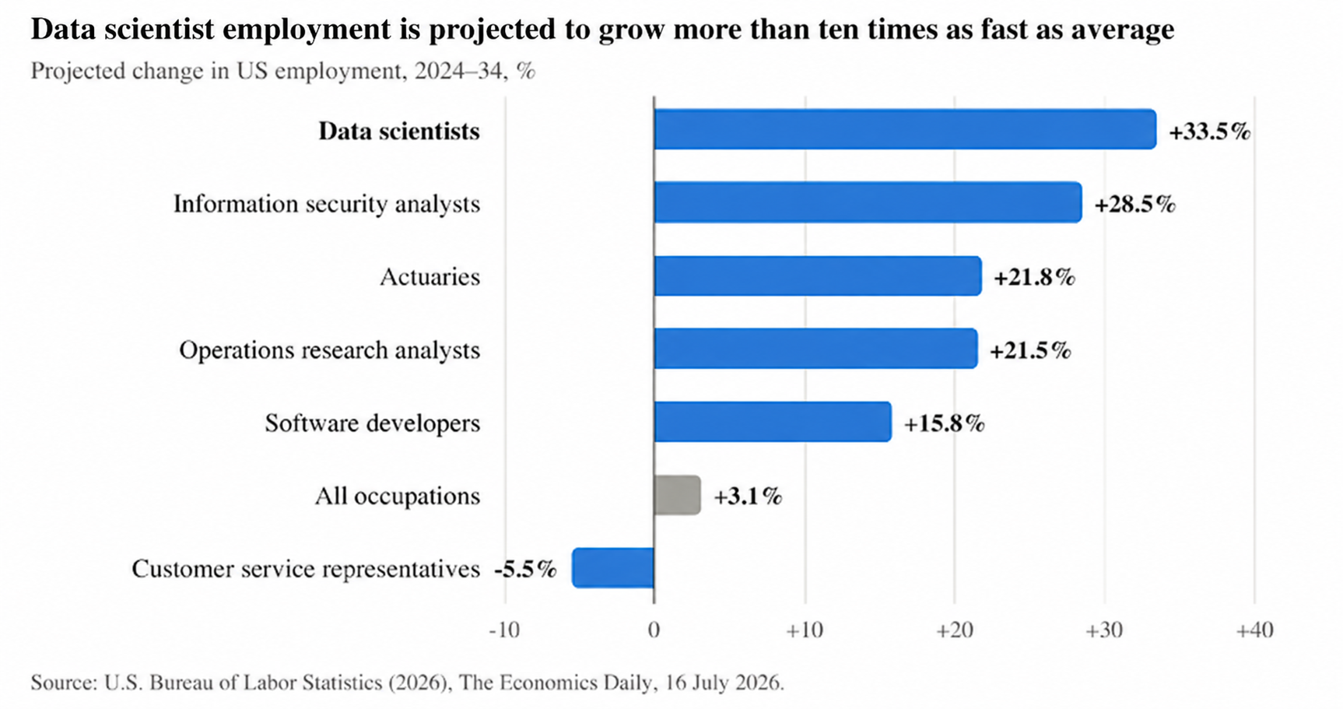
Figure 1. Projected change in US employment, 2024–34, selected occupations. Source: U.S. Bureau of Labor Statistics (2026).
The figure shows strong projected growth in US data scientist employment, making these risks important to address. The next section looks at what the evidence shows about the main changes in data analytics.

2. Evidence and Findings

2.1 Approach and limitations
This policy brief summarizes data from eight recent sources published between 2023 and 2026. Among them are peer‑reviewed studies, a field experiment, labor statistics, and international reports. Taken together, these sources show how artificial intelligence is changing the field of data analysis and which skills may become more important in the future.
However, this review has some limitations. Some of the data comes from international sources and reports on OECD countries, so the findings may not be applicable to all countries. Furthermore, two sources used in this section have not yet been peer-reviewed. Thus, the findings should be considered preliminary rather than final.

2.2 Finding 1: Demand is growing, but the tasks are changing
AI not only reduces the demand for data specialists but also changes the tasks they perform. According to the U.S. Bureau of Labor Statistics (BLS, 2026), the number of jobs for data analysts will grow by 33.5% between 2024 and 2034, which will create about 82,500 new jobs. This indicates that the demand for data specialists will remain high.
At the same time, employers’ requirements for job seekers’ skills are changing. Green (2024), after analyzing data on open vacancies in 10 OECD countries, found that in professions closely related to AI, the share of vacancies requiring emotional, cognitive, or digital skills has increased by 8 percent. Thus, training should be aimed not only at routine programming and data processing but also at developing problem‑solving, communication, interpretation, and AI‑related skills.

2.3 Finding 2: AI helps beginners most—but can also replace them
AI can improve the efficiency of less experienced employees. Brynjolfsson, Lee, and Raymond (2025) found that an AI assistant increased the productivity of customer support employees by an average of 14% and of low‑skilled employees by 34%. This shows that AI can help newcomers perform tasks more efficiently.
However, AI can also reduce the need for low‑skilled employees if it replaces them rather than helping them perform tasks. Brynjolfsson, Chandra, and Chen (2025) found that employment among workers aged 22–25 has declined in those professions where AI is more likely to perform tasks that were previously done by humans. This is a cause for concern, as junior analysts often master routine tasks before moving on to more complex work. Therefore, employers should use AI to support junior employees, rather than simply replacing entry‑level workers with it.

2.4 Finding 3: AI improves work only when people check it
AI can improve the speed and quality of professional work, but only when used correctly. Dell’Acqua et al. (2023) found in a field experiment involving 758 consultants that when using AI within its capabilities, consultants completed 12.2% more tasks, worked 25.1% faster, and their work quality improved by 40%.
But productivity dropped when pushing the AI beyond its limits. This indicates the importance for employees to understand the limits of AI and verify its findings. This is especially important for data analysts, as wrong analysis can lead to bad decisions being made.

2.5 Skills the profession will need
Table 1. Skills data analysts need as AI spreads. Authors’ synthesis based on Dell’Acqua et al. (2023), Green (2024), and World Economic Forum (2025).
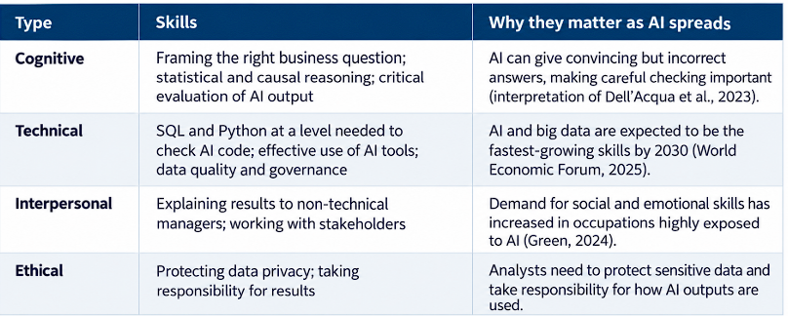
Table 1 shows that AI does not make technical skills less important; it changes their purpose, from producing analysis to checking it, while cognitive and interpersonal skills decide whether results are correct and acted upon.
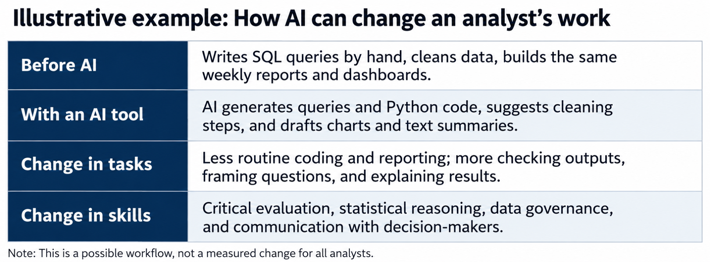
Figure 2. How AI changes the work of a junior data analyst. Illustrative scenario based on Dell'Acqua et al. (2023) and Green (2024).
Figure 2 illustrates how this changes a junior analyst's work, and Section 3 sets out how education and employers can build these skills.

3. Policy Recommendations
Both recommendations follow from the findings above: the first targets the skills gap and the need to verify AI output, and the second targets the shrinking entry route and unclear accountability.

3.1 Recommendation 1: Teach analysts to work with AI—and to check it
Who | Universities with data analytics and data science programs;.
Action | Students apply AI tools to real data and receive a grade for finding and correcting AI errors.
Outcome | Graduates who work productively with AI from day one and know how to recognize its errors have a smaller skill gap. Criteria: employment of the graduates after 6 months, employer reviews.
Evidence | Findings 2–3; World Economic Forum (2025); Dell'Acqua et al. (2023); Brynjolfsson, Li, & Raymond (2025).

3.2 Recommendation 2: Keep the entry route open and set a review standard
Who | Large employers that hire analysts (banks, telecommunications companies, and the overall public sector), as well as professional associations of data specialists.
Action | Option A: Paid training for 6–12 months under the program “Junior Analyst using AI” with a mentor; Option B: a rule stating that any analysis conducted using AI and used to make a decision must be reviewed and approved by the designated analyst; Option C: receiving a professional certificate.
Outcome | Beginner specialists can still enter this profession; decisions made with the help of artificial intelligence are becoming more reliable. Professionalization: training (internship), work organization (time for review is part of job duties), standards (signing rule, certificate), and status (recognized qualification).

References
Brynjolfsson, E., Chandar, B., & Chen, R. (2025). Canaries in the coal mine? Six facts about the recent employment effects of artificial intelligence [Working paper]. Stanford Digital Economy Lab. https://digitaleconomy.stanford.edu/publication/canaries-in-the-coal-mine-six-facts-about-the-recent-employment-effects-of-artificial-intelligence/
Brynjolfsson, E., Li, D., & Raymond, L. (2025). Generative AI at work. The Quarterly Journal of Economics, 140(2), 889–942. https://doi.org/10.1093/qje/qjae044
Dell'Acqua, F., McFowland, E., III, Mollick, E., Lifshitz-Assaf, H., Kellogg, K. C., Rajendran, S., Krayer, L., Candelon, F., & Lakhani, K. R. (2023). Navigating the jagged technological frontier: Field experimental evidence of the effects of AI on knowledge worker productivity and quality (Harvard Business School Working Paper No. 24-013). https://doi.org/10.2139/ssrn.4573321
Eloundou, T., Manning, S., Mishkin, P., & Rock, D. (2024). GPTs are GPTs: Labor market impact potential of LLMs. Science, 384(6702), 1306–1308. https://doi.org/10.1126/science.adj0998
Green, A. (2024). Artificial intelligence and the changing demand for skills in the labour market (OECD Artificial Intelligence Papers, No. 14). OECD Publishing. https://doi.org/10.1787/88684e36-en
OECD. (2024). How is AI changing the way workers perform their jobs and the skills they require? (OECD Policy Brief). OECD Publishing. https://doi.org/10.1787/8dc62c72-en
U.S. Bureau of Labor Statistics. (2026, July 16). Artificial intelligence, information technology, and employment, 2024–34. The Economics Daily. https://www.bls.gov/opub/ted/2026/artificial-intelligence-information-technology-and-employment-2024-34.htm
World Economic Forum. (2025). The future of jobs report 2025. https://www.weforum.org/publications/the-future-of-jobs-report-2025/

